Network Access of External Party into TMCZ

Table of Contents
1. intro 1
2. Configuration and settings 1
3. LAN IP address (on TMCZ premises FOR DOMAIN COMPUTERS ONLY) 2
3.1 802.1x protocol Settings (MS Windows 10) 2
3.2 Update and Patching of Supplicant 3
3.3 802.1x Supplicant Setup 3
4. NTLM Authentication level setup (WINDOWS 10) 5
5. IAM ROLES FOR DOMAIN AND VPN ACCESS 5
6. Intranet Access 5
7. mailbox access on Exchange 5
8. Outlook settings 5
9. Domain password change 5
10. CliENT Remote access (VPN) 5
10.1 VPN certificate import (Manual certificate installation only) 6
10.2 Logging-In by Cisco AnyConnect 6
10.3 VPN authentication and authorization 6
11. Default IP communication in TMCZ NETWORK 6
12. Problem solving 7
VPN Client cannot connect 7

An External party acknowledges that electronic communication (e.g. email, web traffic, USB drives, etc.) within TMCZ are a subject of continuous automated logging and monitoring by the DLP system (Data Leak Prevention) on the basis of leakage-prevention of personal and telecommunication data.

intro
A Guide for external parties which need a network access to TMCZ computer domain.
SW requirements, certificates, guides are on http://cert.t-mobile.cz/vpn/

Configuration and settings
The services and management of external parties is governed by internal TMCZ processes.
The access credentials (login, password) are provided by TMCZ contact person who requests internal identity in IAM system. The computer shall be setup in following areas:
- WiredAutoconfig service (protocol 802.1x) for LAN Network Access of TMCZ, see point 3,
- NTLMv2, see point 4,
- VPN Access (Cisco AnyConnect client), see point 10.
Attention:
When logging in for the first time, it is necessary to change the password.
The domain password does not expire during the active working contract.
Please change the password immediately it is compromised or you have a suspicion of compromising.
The domain passwords are periodically tested. If the password is evaluated as weak the user is notified by email and he is requested to change the weak password.
Work in TMCZ Domain requires to put user account in following form: RADIOMOBIL-KSP\extnovakt or rdm.cz\extnovakt or tomas.novak@external.t-mobile.cz. Logging in TMCZ VPN GW requires only your domain name (domain itself is preset on GW).

LAN IP address (on TMCZ premises FOR DOMAIN COMPUTERS ONLY)
LAN IP address is provided for dynamically (DHCP).
Settings: Control Panel – Network Connections - LAN Properties – Internet protocol (TCP/IP) - Obtain an IP address automatically
LAN access is based on authentication via protcol 802.1x EAP/TLS which uses:
- User Personal Certificate enrolled to a station from TMCZ certification authority (also point 10),
- User Domain Account and Password.
Access to special sites/web which are not accesible directly from TMCZ Office network uses proxy.pac file:
- Use automatic configuration script”
- Fill-in “Address“: http://rdmproxy.rdm.cz:9002/proxy.pac

802.1x protocol Settings (MS Windows 10)
Start „Wired AutoConfig Service“ (service name „dot3svc“) on the station. The service starts a native supplicant 802.1x in Windows, which controls network access. Use „automatical start“of the service.
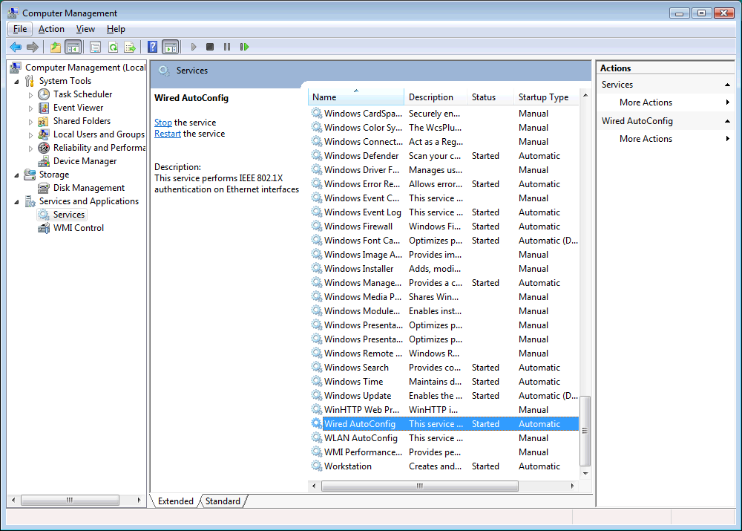
Picture 1 - Service “Wired AutoConfig”

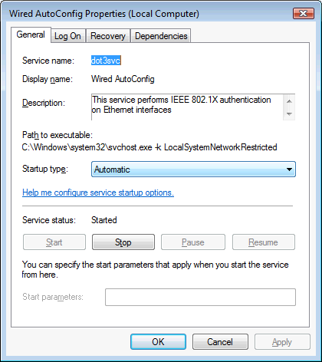
Picture 2 - Detailed setup of "Wired AutoConfig Service"

Update and Patching of Supplicant
802.1x native supplicant needs the following Patches to be installed (if not implemented in OS):

- http://support.microsoft.com/kb/980295/en-us
- http://support.microsoft.com/?kbid=976373
- http://support.microsoft.com/kb/2481614/en-us
- https://support.microsoft.com/en-us/kb/2736878
- https://support.microsoft.com/en-us/kb/2837558
Please setup EAP blocking period on the station by a command:
netsh lan set blockperiod value=0

802.1x Supplicant Setup
Control panel - Network and Sharing Center - Change Adapter Settings - Ethernet - Ethernet Properties – Authentication (setings mentioned in the picture 3).

Settings:
- Check „Enable IEEE 802.1X authentication“
- Check „Choose a network authentication method“: Microsoft: Smart Card or other certificate
- Check „Fallback to unauthorized network access“
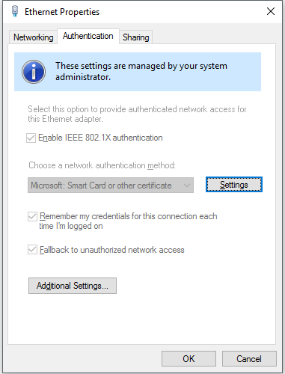
Picture 3 - 802.1x native supplicant Setup
Detailed configuration shall be as follows:
- Check „Verify the server’s identity by validating the certificate“,
- Uncheck „Connect to these servers“
- Uncheck „Don’t prompt user to authorize new servers or trusted certification authorities“.
Advanced Settings shall be as follows:
- Check „Specify authentication mode“
- Choose „User and computer authentication“
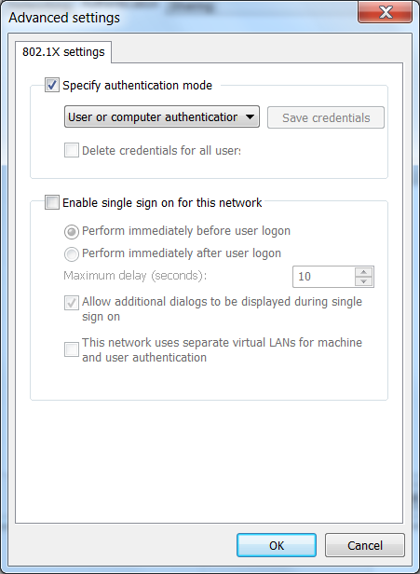
Picture 4 – Advanced settings

NTLM Authentication level setup (WINDOWS 10)
Setup the „Local Security Policy“ as follows:
- In Start menu write „Local Security Policy“,
- In an opened window choose the following options: – Local Policies – Security Options,
- In Security Options look for the raw stating „Network Security: LAN Manager Authentication level“,
- On the right side choose an option „Send NTLMv2 response only. Refuse LM & NTLM“

IAM ROLES FOR DOMAIN AND VPN ACCESS
IAM system rules Identity Management and Access of all TMCZ employees (internal and external).
External Identities needs following IAM roles:
- For TMCZ Domain Account following role is required: [AD:EXTERNISTE] BASIC_EXTERNISTE
- For VPN and Network communication the following role is required: [VPN] extStandard_CZ for a standard consultant or [VPN] extAdminIT_CZ for a technical consultant,
- For TMCZ Exchange server access and email the following role is required:
[AD:EXTMAIL] Mailbox_pro_externisty
- For External email usage in TMCZ systems (lAM, etc) the following role is required:
[AD:EXTMAIL] Zobrazit_externi_email_v_Outlooku

Intranet Access
https://intranet.fed.tmo/ (network access granted by default)

Intranet access requires user authentication, on domain stations is supported by Single Sign On (SSO) and no further authentication is required.
On non-domain stations the authentication is required every time station/user accesses the intranet.

mailbox access on Exchange
Access is allowed from TMCZ network to link:
https://mail.dt-one.com/owa/auth/logon.aspx?replaceCurrent=1&url=https%3a%2f%2fmail.dt-one.com%2fowa

Use domain login name and password: e.g. RADIOMOBIL-KSP\extnovakt

Outlook settings
Outlook client configuration requires a new profile.
Setup: Control Panel – Mail – Show Profiles – Add
- Type profile name, press “OK”
- Choose Service – “Microsoft Exchange Server or compatible service”
- Exchange server: mail.dt-one.com
- User Name: pavel.novak@external.t-mobile.cz
- You can configure which profile is being used by default, or Outlook shall ask at startup.

Domain password change
Password can be set/reset on link: https://eamint.telekom.sk/eam/reset-password

CliENT Remote access (VPN)
VPN Remote Access requires installation of:
- VPN client software Cisco AnyConnect – download on http://cert.t-mobile.cz/vpn/
- VPN certificate for domain stations (owned by TMCZ) – personal certificates are enrolled automatically from TMCZ CA,
- VPN certificate for non-domain stations (owned by external party) are generated by IT security department - request are sent by an internal TMCZ manager responsible for external employee (Service Desk template “Certificates”),
- For a higher security the 2nd Factor is used in form of SMS messages sent by TMCZ authentication server to External Consultant Mobile device (Please provide a valid mobile number).
VPN Client profile is configured during logging in by xml file provided by TMCZ VPN GW (Default GW, DNS, etc).

VPN certificate import (Manual certificate installation only)
If VPN certificate must be issued manually then following process is to used:
- Copy the certificate file into computer file system,
- If needed rename it to .pfx extension,
- For installation double-click .pfx certificate file (do not change any settings and let OS to choose a location),
- Check successful installation of VPN certificate in IE (see picture below Tools, Internet options, Content, Certificates), or in Manage User Certificates (certmgr.msc).

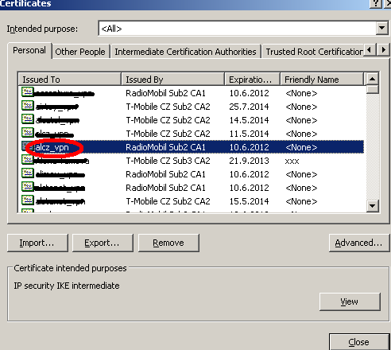

Logging-In by Cisco AnyConnect
Start the Cisco AnyConnect Client by doubleclicking its icon (in Start Menu, Programs, Taskbar). Fill in VPN gateway rzt-vpn-emp.t-mobile.cz or ctx-vpn-emp.t-mobile.cz and click “Connect”.
The user is then asked for providing SMS token sent to his/her mobile device.
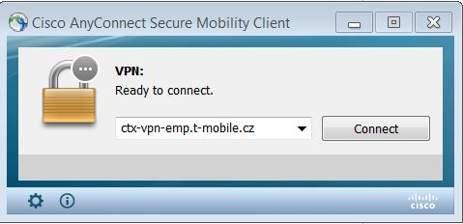

VPN authentication and authorization
Both VPN GW certificate and VPN client certificate are validated against CA CRL list. VPN GW then sends user identity towards Domain Controller to check groups a user belongs to and group policies (for domain station only).
Based on group membership the user is provided network settings and allowed communication (controlled by NGFW).
After VPN tunnel is established the traffic is routed through it (except for split tunnel routes if allowed).

Default IP communication in TMCZ NETWORK
Default intranet communication includes: internet, intranet web, sharedir, sharepoint, mail servers.
A communication to other TMCZ or STSK servers and services depends on IAM membership (role management).

If Default communication is to be extended to other network resources and services a request must be sent to application TUFIN (FW management) on https://fw.telekom.sk.

Problem solving

VPN Client cannot connect
- In a case of unsuccessful authentication please check username and password, request new SMS token,
- Check validity/expiration of user identity and its roles in IAM,
- change/reset password on https://eamint.telekom.sk/eam/reset-password,
- check internet connectivity (access to internet web pages),
- check IP connectivity to VPN GW: click Start>Run>type “cmd”>press Enter; on Command Prompt window type: “ping ctx-vpn-emp.t-mobile.cz” or “ping rzt-vpn-emp.t-mobile.cz” and press Enter
- If VPN GW is on site, you will see successful output with roundtrip time (RTT),
- If there is no reply with RTT, you are not connected to internet or ping is blocked – please consult to your network provider,
- If ping is working and Cisco VPN client is not working, double-check the settings and/or restart VPN client,

PLEASE NOTE:

TMCZ supports the domain stations only.

For issues on foreign (non TMCZ) stations please contact support in your company.

Issues related to TMCZ/STSK network shall be reported in Service Desk (CSMT JIRA).

